Masked Autoencoder (MAE) in Medical Area
In the medical field, obtaining high-quality, annotated datasets is a significant setback. Re-imaging patients’ pictures (ex. CT/MRI) due to blurriness or artificial organs is often unfeasible due to cost and radiation risks. Masked Autoencoders (MAE) address this problem by learning the underlying structure of medical data through reconstruction, effectively "filling in the blanks" when data is incomplete or unlabeled.
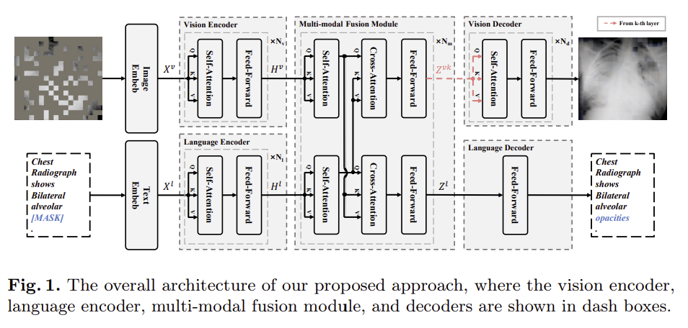
When we tried to run MAE on medical (VQA-RAD) images, we achieved a Mean Squared Error (MSE) of 0.1716, which translates to a Reconstruction Fidelity of 82.84%. Despite a high masking ratio of 75%, the model demonstrated a robust ability to infer missing anatomical structures. Furthermore, the standard deviation of 0.1099 indicates that the model's performance remains consistent across diverse radiological samples, proving its potential as a reliable tool for enhancing or reconstructing low-quality medical imagery without additional radiation exposure.

Secondary Studies
According to the study on Multi-Modal Masked Autoencoders, medical diagnosis is rarely based on images alone; it involves a synergy between vision (X-rays/CT) and language (radiology reports). MAE facilitates Vision-and-Language Pre-training (VLP) by masking both image patches and text tokens. This allows the model to learn cross-modal correlations, helping the AI understand how specific visual patterns in an MRI relate to technical descriptions in a clinical report.
Also, while MAE may provide powerful representations, for practical deployment one requires efficiency. Insights from Lightweight Face Recognition and Hierarchical Reshaping models suggest that the hierarchical optimization can refine the reconstruction process. In a medical context, this means the model can focus on the "reshaping" critical anatomical features with high precision while remaining computationally efficient enough for real-time hospital use.
Overall, MAE shifts the paradigm from requiring massive labeled datasets to leveraging the inherent structure of medical images and text. By reconstructing masked information, these models provide a robust foundation for more accurate, multimodal, and efficient diagnostic tools.

